Challenge Number: 995
Played on date: November 2, 2019 Time: 12:00
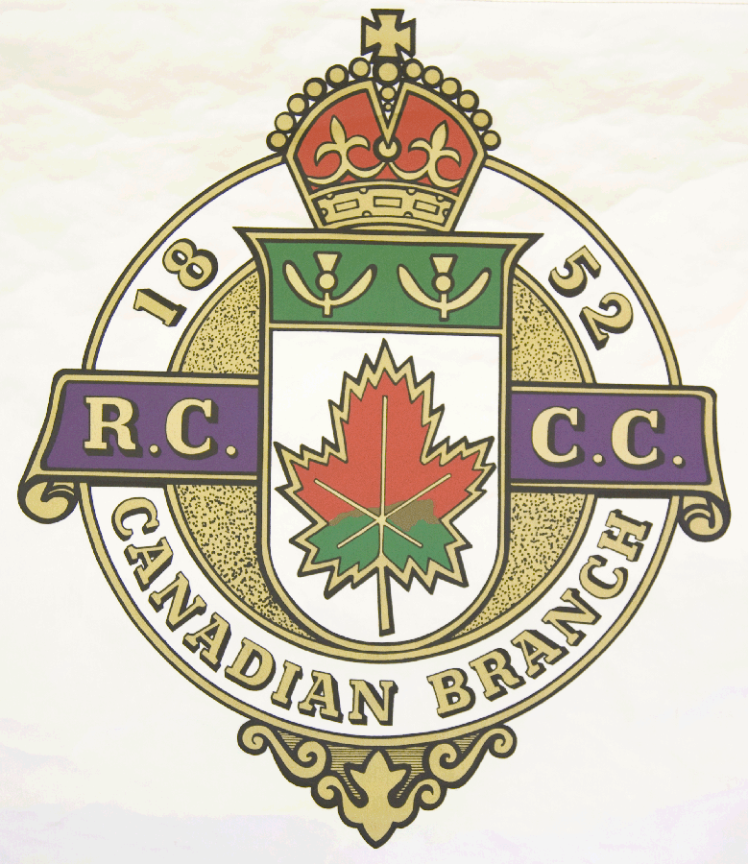
Hosting Club: Pembroke Curling Club

Host Club Address: 428 Herbert Street

Host Club City: Pembroke, Ontario

Host Club Telephone: 613 - 732 - 4113

Host Contact Person: David Trautrim

Contact phone or email: dtrautrim@gmail.com

Hosting Club: Pembroke Challenging Club: North Grenville

Skip: Mike Thompson Skip: David Brown

Third: Stephen Alles Third: David Roy

Second: Bill Cheliak Second: Mitch Barsalou

Lead: Gerry Genoa Lead: Richard Levesque

Skip: Jeff Faught Skip: Robert Kluke

Third: Rod White Third: Kevin Cook

Second: Larry Smith Second: Mike O’Brien

Lead: Keith Selle Lead: Mark Payment .

 | Skip | 1 | 2 | 3 | 4 | 5 | 6 | 7 | 8 | 9 | 10 | Score
Sheet | Thompson |  |  |  | 2 |  | 2 | 1 |  |  | 2 | 7
Sheet | Brown | 2 | 1 | 1 |  | 1 |  |  | 1 | 2 |  | 8
Sheet | Faught | 2 | - |  |  | 2 | 2 |  | 1 | 3 | 1 | 11
Sheet | Kluke |  | - | 5 | 1 |  |  | 1 |  |  |  | 7

Hosting club Score: 18____ Challenging club score: __ 15____

Note: Description of the game should follow on separate page as well as photos of the teams.

